**VIVEKANAND EDUCATION SOCIETY’S INSTITUTE OF TECHNOLOGY**

**(An Autonomous Institute Affiliated to University of Mumbai**

**Department of Computer Engineering)**

**Department of Computer Engineering**

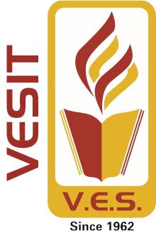

**Project Report on**

# Kisan Setu

Submitted in fulfillment of the requirements of Third Year (Semester–VI), Bachelor of Engineering Degree in Computer Engineering at the University of Mumbai

Academic Year 2024-25

by

**Rohit Motwani / D12C / 70**

**Mohit Advani / D12C / 02**

**Santosh Hinduja / D12C / 68**

**Varun Dulani / D12C / 21**

**Project Mentor**

**Prof.** Pallavi Gangurde

**University of Mumbai**

**(AY 2024-25)**

**VIVEKANAND EDUCATION SOCIETY’S INSTITUTE OF TECHNOLOGY**

**(An Autonomous Institute Affiliated to University of Mumbai**

**Department of Computer Engineering)**

**Department of Computer Engineering**



**CERTIFICATE**

This is to certify that **Rohit Motwani, Mohit Advani, Santosh Hinduja, Varun Dulani** of Third Year Computer Engineering studying under the University of Mumbai has satisfactorily presented the project on “**Kisan Setu**” as a part of the coursework of Mini Project 2B for Semester-VI under the guidance of Prof. Pallavi Gangurde in the year 2024-25.

______***_______________***

Date

| __________________ |  | __________________ |
| --- | --- | --- |
| Internal Examiner |  | External Examiner |

_________________ __________________ __________________

Project Mentor Head of the Department Principal

Prof. Pallavi Gangurde Dr. Mrs. Nupur Giri Dr. J. M. Nair

# Mini Project Approval

This Mini Project entitled “Kisan Setu**”** by **Rohit Motwani (70), Mohit Advani (02), Santosh Hinduja (68), Varun Dulani (21)** is approved for the degree of **Bachelor of Engineering** in **Computer Engineering.**

**Examiners**

**1………………………………………**

(Internal Examiner Name & Sign)

## 2…………………………………………

(External Examiner name & Sign)

Date:

Place

**Declaration**

We declare that this written submission represents our ideas in our own words and where others' ideas or words have been included, we have adequately cited and referenced the original sources. We also declare that we have adhered to all principles of academic honesty and integrity and have not misrepresented or fabricated or falsified any idea / data / fact / source in our submission. We understand that any violation of the above will be cause for disciplinary action by the Institute and can also evoke penal action from the sources which have thus not been properly cited or from whom proper permission has not been taken when needed.

| -----------------------------------------  (Signature)  Rohit Motwani (70)  -----------------------------------------  (Signature)  Santosh Hinduja (68) | -----------------------------------------  (Signature)  Mohit Advani (02)  -----------------------------------------  (Signature)  Varun Dulani (21) |
| --- | --- |
| Date: |  |

## ACKNOWLEDGEMENT

We are thankful to our college Vivekanand Education Society’s Institute of Technology for considering our project and extending help at all stages needed during our work of collecting information regarding the project.

It gives us immense pleasure to express our deep and sincere gratitude to Assistant Professor **Pallavi Gangurde** (Project Guide) for her kind help and valuable advice during the development of project synopsis and for her guidance and suggestions.

We are deeply indebted to Head of the Computer Department **Dr. (Mrs.) Nupur Giri** and our Principal **Dr. (Mrs.) J.M. Nair ,** for giving us this valuable opportunity to do this project.

We express our hearty thanks to them for their assistance without which it would have been difficult in finishing this project synopsis and project review successfully.

We convey our deep sense of gratitude to all teaching and non-teaching staff for their constant encouragement, support and selfless help throughout the project work. It is a great pleasure to acknowledge the help and suggestion, which we received from the Department of Computer Engineering.

We wish to express our profound thanks to all those who helped us in gathering information about the project. Our families too have provided moral support and encouragement several times.

### Computer Engineering Department

**COURSE OUTCOMES FOR T.E MINI PROJECT 2B**

Learners will be to:-

| **CO No.** | **COURSE OUTCOME** |
| --- | --- |
| CO1 | Identify problems based on societal /research needs. |
| CO2 | Apply Knowledge and skill to solve societal problems in a group. |
| CO3 | Develop interpersonal skills to work as a member of a group or leader. |
| CO4 | Draw the proper inferences from available results through theoretical/ experimental/simulations. |
| CO5 | Analyze the impact of solutions in societal and environmental context for sustainable development. |
| CO6 | Use standard norms of engineering practices |
| CO7 | Excel in written and oral communication. |
| CO8 | Demonstrate capabilities of self-learning in a group, which leads to lifelong learning. |
| CO9 | Demonstrate project management principles during project work. |

**Index**

**Title :-** Kisan Setu **Page no**

**Abstract.** 10

**Chapter 1: Introduction.** 11

1.1 Introduction 11

1.2 Motivation. 12

1.3 Problem Definition. 13

1.4 Existing Systems 14

1.5 Lacuna of the existing systems 15

1.6 Relevance of the Project. 16

**Chapter 2: Literature Survey** 17

A. Overview of Literature Survey

**Chapter 3: Requirement Gathering for the Proposed System**

3.1 Introduction to requirement gathering. 19

3.2 Functional Requirements. 20

3.3 Non-Functional Requirements. 21

3.4.Hardware, Software , Technology and tools utilized. 22

3.5 Constraints. 23

**Chapter** 4**: Proposed Design**

4.1 Block diagram of the system. 24

4.2 Modular design of the system. 25

4.3 Detailed Design. 26

4.4 Project Scheduling & Tracking : Gantt Chart. 27

**Chapter 5: Implementation of the Proposed System**

5.1. Methodology Employed. 28

5.2 Algorithms and flowcharts. 28

**Chapter 6: Results and Discussion**

6.1. Screenshots of User Interface (GUI) 31

6.2. Input Parameters / Features considered. 33

6.3. Comparison of results with existing systems. 34

6.4. Inference drawn. 34

**Chapter 7: Conclusion**

7.1 Limitations 37

7.2 Conclusion. 37

7.3 Future Scope. 37

**Reference**   38

**Appendix**

1. List of Figures. 39
2. List of Tables. 39

**Abstract**

The Kisan Setu project is designed to establish a comprehensive platform that not only educates farmers on the benefits and techniques of organic farming but also guarantees a marketplace for their organic produce. The initiative aims to address several critical issues within the agricultural sector, particularly the challenges faced by farmers who wish to transition to sustainable, organic farming practices but lack the necessary resources, knowledge, and market access. The platform will provide farmers with essential information on organic farming methods, soil health, pest management, and crop rotation, enabling them to make informed decisions and adopt eco-friendly practices. In addition, it will offer technology tools for tracking farming activities, ensuring that all practices align with organic standards. One of the project's core goals is to create a reliable and sustainable marketplace where farmers can sell their organic produce at fair prices, removing the uncertainty that often comes with market fluctuations. By empowering farmers with education, technology, and market access, Swachh Harvest aims to foster a shift towards environmentally sustainable farming, reduce dependency on harmful chemicals, and improve the quality of produce, benefiting both farmers and consumers alike.

**Introduction**

**1.1 Introduction**

KisanSetu, a web app, focuses on organic farming as a sustainable practice that suits agricultural development by providing the dual benefit to the environment and human health. It is in consonance with nature, fosters biodiversity, enhances soil health, and minimizes resorting to harmful chemicals or synthetic fertilizers. Yet, the realization of organic farming has always lagged behind a series of challenges even though it has its benefits. They include the unawareness of benefits, access to organic products, and lack of information concerning support from the government for farmers.

KisanSetu seeks to bridge these gaps with a common platform for organic farming practices to bridge the communication between farmers at large, consumers, and the stakeholders. This platform provides a vast range of information through how-to guides, videos, and expert articles on organic farming practices.

Besides the educational content, Kisan Setu also features an online marketplace for trading organic goods between farmers and consumers. The marketplace section of this platform promotes a direct bond between producers of organic products and health-conscious buyers, opening up an online store on organic food, produce, and eco-friendly agricultural inputs. SwachhHarvest guarantees fair prices to the farmers, while consumers benefit by buying fresh, high-quality, and certified organic products at these rates by eliminating intermediaries.

In addition, SwachhHarvest keeps farmers informed on government schemes, subsidies, and certifications that support organic farming. The platform also keeps its users informed about various agricultural policies, funding opportunities, and compliance requirements. This feature makes it easier for farmers to obtain financial and logistical assistance to sustain and scale up farming, thus encouraging organic agriculture.

KisanSetu, a web app, focuses on organic farming as a sustainable practice that suits agricultural development by providing the dual benefit to the environment and human health. It is in consonance with nature, fosters biodiversity, enhances soil health, and minimizes resorting to harmful chemicals or synthetic fertilizers. Yet, the realization of organic farming has always lagged behind a series of challenges even though it has its benefits. They include the unawareness of benefits, access to organic products, and lack of information concerning support from the government for farmers.

**1.2 Motivation**

The motivation behind KisanSetu stems from the growing global demand for organic farming and the numerous environmental and health benefits it offers. As the world grapples with the harmful effects of synthetic fertilizers, pesticides, and industrial farming practices, there has been a growing realization of the importance of sustainable agriculture. Organic farming, which is in harmony with nature, promotes biodiversity, improves soil health, and produces healthier food without harmful chemicals, has emerged as a solution to these pressing concerns. However, despite its clear advantages, organic farming has been slow to gain traction, particularly in regions where traditional farming practices still dominate. This has been largely due to a lack of awareness, limited access to organic products, and insufficient knowledge about the support available from the government.

KisanSetu seeks to address these gaps by providing farmers with a platform that not only educates them on the benefits and practices of organic farming but also connects them with resources, tools, and markets to thrive. Many farmers still struggle with making the switch to organic farming due to a lack of clear guidance, market outlets for organic products, and awareness of the government schemes that can support them. This platform bridges these gaps by offering comprehensive educational content such as how-to guides, expert articles, and videos on sustainable farming techniques. By doing so, it empowers farmers with the knowledge needed to make informed decisions and adopt environmentally friendly farming practices.

Additionally, KisanSetu is motivated by the desire to create a transparent and fair marketplace that benefits both farmers and consumers. The platform ensures that farmers receive fair prices for their organic produce, eliminating the need for intermediaries, which often reduce farmers' profits. Consumers, on the other hand, can purchase fresh, high-quality, and certified organic products, knowing they are supporting sustainable farming practices. This two-way connection between producers and buyers not only strengthens the organic farming community but also promotes healthy consumption habits. By integrating these various aspects—education, marketplace, government support, and community building—KisanSetu aims to make organic farming a viable and attractive option for farmers, ensuring a sustainable future for agriculture.

KisanSetu is motivated by the need to empower farmers with the tools and resources required for successful organic farming. Transitioning to organic practices can be challenging, but the platform provides practical solutions like crop and soil tracking tools to help farmers make informed, sustainable decisions. Additionally, by offering access to government schemes, subsidies, and certifications, **KisanSetu** boosts farmers' confidence in adopting organic methods, ensuring that they can sustain and grow their businesses while benefiting both economically and environmentally.

**1.3 Problem Definition**

The problem addressed by KisanSetu revolves around the challenges faced by farmers in adopting organic farming practices, including a lack of awareness about its benefits, limited access to organic products, and insufficient information on available government support. Despite the environmental and health advantages of organic farming, many farmers are reluctant to make the transition due to the absence of guidance, reliable market outlets, and financial assistance. Additionally, the lack of a direct connection between producers and consumers further limits farmers' ability to sell their organic produce at fair prices, hindering the growth of sustainable agricultural practices. KisanSetu aims to bridge these gaps by providing a comprehensive platform that offers education, market access, and support resources for farmers transitioning to organic farming.

#### 

#### Objectives

1. **Educate Farmers :-** Provide detailed resources such as how-to guides, videos, and expert articles on organic farming practices to increase awareness and knowledge.
2. **Promote Sustainable Practices :-** Encourage the adoption of eco-friendly farming methods that enhance soil health, biodiversity, and reduce dependency on harmful chemicals.
3. **Create a Marketplace :-** Establish a platform for farmers to directly sell their organic produce to consumers, ensuring fair prices by eliminating intermediaries.
4. **Provide Government Support Information :-** Keep farmers informed about available government schemes, subsidies, and certifications that support organic farming.
5. **Offer Tracking Tools :-** Provide farmers with tools to track and manage agricultural activities such as crop growth, soil health, and organic input usage.
6. **Foster a Community :-** Build a platform for farmers to interact, share experiences, and collaborate, strengthening the organic farming community.

**1.4 Existing Systems**

Farmers' Cooperative Platforms offer networks for farmers to sell their produce and exchange knowledge. Some also provide organic certification services. However, these platforms often lack comprehensive access to organic farming resources and usually focus only on local markets, leaving a gap in the broader integration of organic farming education and market access. [1], [6]

Government Agricultural Portals provide information on available subsidies, schemes, and policies, along with training programs for farmers. However, these portals generally don't offer detailed guidance on organic farming practices and are often not user-friendly or tailored to the specific needs of organic farmers. [3]

Organic Certification Websites primarily help farmers obtain certification for organic produce and offer educational content about organic standards. However, they are limited to certification processes and don't provide ongoing support for farmers transitioning to or managing organic farming practices. Moreover, they can incur additional costs for certification. [1]

Online Marketplaces such as Amazon and Flipkart provide platforms for selling organic products, offering farmers a large consumer reach. However, these platforms are highly competitive and do not facilitate a direct connection between producers and consumers. Additionally, they do not focus on organic farming education or offer tools to support farmers. [6]

Local Organic Farming Communities foster knowledge-sharing and promote organic farming on a local level. While these communities are supportive, their reach is limited, and they often don't provide access to broader markets or government schemes. Additionally, they lack integration with online tools that could help farmers scale their operations. **[1], [6]**

**1.5 Lacuna of the existing systems**

The existing systems for supporting organic farming have several lacunae that limit their effectiveness. One significant gap is limited access to market reach, as farmers typically rely on local markets, which restrict their ability to sell to a larger consumer base. This limitation often results in reduced profits as farmers have to sell to intermediaries. The demand for organic products is also inconsistent in local markets, making it difficult for farmers to predict sales and plan their farming activities. Additionally, these systems lack online marketplace integration, preventing farmers from directly connecting with consumers, which would eliminate the need for intermediaries and potentially increase their revenue [6].

Another critical issue is the lack of continuous support for farmers. Existing platforms primarily offer one-time guidance, such as providing certification or basic information about organic farming, but fail to deliver ongoing assistance [1][2]. Farmers need continuous access to updated educational material, expert advice, and real-time solutions to the challenges they face in their day-to-day farming practices. Moreover, current systems do not offer technical guidance on specialized organic farming techniques like pest control, crop rotation, or managing soil health, which are crucial for maintaining sustainable and successful organic farms [2][4].

Additionally, fragmented information sources create confusion among farmers. With information spread across blogs, forums, agricultural offices, and websites, it becomes difficult for farmers to find consolidated and reliable resources [6]. Furthermore, much of the information provided is not tailored to the specific regions or climates in which farmers operate, leading to inefficiencies in implementing organic farming practices [3][7]. This lack of reliable, region-specific information hinders farmers from making informed decisions. Without access to a centralized platform, they are often left to navigate these various sources, which can be time-consuming and overwhelming.

Moreover, many existing systems fail to foster a direct producer-consumer connection, which is crucial for building trust and transparency. Online marketplaces such as Amazon or local e-commerce platforms typically facilitate sales but do not create a direct link between farmers and consumers. This absence of interaction means consumers are less informed about the source of their food, and farmers miss out on the opportunity to develop loyal customer relationships [5][6]. Additionally, farmers often face high competition from non-organic products, which can overshadow organic goods in these marketplaces, reducing their visibility and affecting sales. Without a direct connection, farmers cannot establish a transparent brand or communicate the value of their organic practices, leading to reduced consumer confidence and lower demand for their products [5].

**1.6 Relevance of the Project**

* **Promotes Sustainable Agriculture :-** The project encourages organic farming practices that are environmentally friendly, reduce the use of harmful chemicals, and support long-term soil health and biodiversity [2][4][5].
* **Bridges the Knowledge Gap :-** By offering educational content such as expert articles, how-to videos, and guides, the platform empowers farmers with up-to-date knowledge about organic farming methods [1][2][6].
* **Improves Market Accessibility :-**It provides an online marketplace that directly connects organic farmers with consumers, eliminating intermediaries and ensuring fair prices for both parties [6].
* **Supports Government Initiatives :-** The platform aligns with national and global movements toward sustainable agriculture and supports farmers by sharing information on relevant government schemes, subsidies, and certifications [3][7].
* **Encourages Economic Development :-** By helping farmers access better markets and financial resources, the project contributes to the socio-economic development of rural communities [6][7]
* **Builds Transparency and Trust :-** It fosters direct relationships between producers and consumers, increasing transparency about food sources and building trust in organic products [5][6].
* **Addresses Current Market Limitations :-** The project overcomes the limitations of existing systems, such as lack of continuous support and fragmented information, by offering a centralized, farmer-friendly platform [1][2][6].

**Literature Survey**

**A. Overview of Literature Survey**

| **Paper Title** | **Inference** |
| --- | --- |
| 1.An in-depth Analysis of the Elements Shaping Organic Farmers: A Systematic Review[4] | 1. DTW enables accurate comparison of organic crop production patterns across cities by handling variations in time and speed.  2. Insights depend on data quality, and DTW’s computational cost can be high for large datasets. |
| 2. Performing similarity analysis on organic farming crop data of Turkish Cities. [4] | 1. DTW effectively analyzes time-series data by aligning crop production sequences across cities, enabling the detection of meaningful patterns despite timing differences.  2. Study outcomes depend on data quality, and DTW’s computational intensity poses challenges when applied to large or complex datasets. |
| 3.Optimizing Organic Food Sustainability Through Digital Platforms for Enhanced SEO [5] | 1. Digital algorithms enhance consumer engagement by offering personalized recommendations, analyzing sentiments, and predicting market trends, thereby supporting the promotion and sustainability of organic food.  2. Effectiveness is limited by data accuracy and development costs, along with consumer trust issues, which can hinder the impact of digital marketing strategies. |
| 4. Design and Implementation of E-Commerce Platform for Characteristic Agricultural Products [5] | 1. Algorithms improve efficiency and accessibility by optimizing supply chains, forecasting demand, and personalizing product recommendations, leading to better availability and user satisfaction.  2. Challenges include high initial costs and the need for quality data, which may impact scalability and effectiveness in large-scale operations. |
| 5. Agro World: A Naive Bayes based System for Providing Agriculture as a Service [6] | 1. Integration of predictive algorithms streamlines farming decisions, with Naive Bayes enhancing crop and yield forecasts and Apriori personalizing e-commerce recommendations for farmers.  2. Performance depends on data quality and scalability, as limitations in historical data or increased system complexity may reduce prediction accuracy and recommendation efficiency. |
| 6. Organic Food Online Shopping Intention [6] | 1. Integration of predictive algorithms streamlines farming decisions, with Naive Bayes enhancing crop and yield forecasts and Apriori personalizing e-commerce recommendations for farmers.  2. Performance depends on data quality and scalability, as limitations in historical data or increased system complexity may reduce prediction accuracy and recommendation efficiency. |
| 7. Continuous Purchase Intention from E-Marketplace: A case study of Organic Agricultural Products [5] | 1. Consumer behavior analysis using clustering and regression revealed key factors—like health awareness and perceived product quality—that drive continued interest in organic products post-Covid-19.  2. Findings may not be universally applicable due to self-reported data biases and a narrow focus on a specific market segment. |
| 8. Integration of Information and Communication Technologies in Agriculture for Farm Management and Knowledge Exchange [3] | 1. OpenHub enhances farm management by unifying diverse agricultural data sources, enabling real-time insights and promoting sustainable practices through predictive analytics.  2. Scalability and adaptability remain challenges, especially when dealing with very large datasets or integrating new data types into the existing system. |
| 9. A Systematic Review of the Soil Fertility Monitoring and Organic Farming Techniques for an Improved Crop Yield. [4] | 1. Predictive models enhance crop yield accuracy by analyzing environmental factors and historical data, improving resource usage and agricultural productivity.  2. Limitations persist in accounting for unpredictable changes in climate or soil, and models may not be universally applicable across all regions or crop types. |
| 10. Organic farming: Technology for environment-friendly agriculture [1] | 1. Organic farming technology improves sustainability by optimizing crop rotation, pest control, and resource allocation, resulting in better soil health and reduced environmental impact.  2. Challenges remain during the transition phase, including lower yields, higher labor costs, and scalability issues, which require ongoing research and adaptation to local conditions. |

Table no.1 Literature Survey

**Chapter 3: Requirement gathering for the Proposed System**

**3.1 Introduction to requirement gathering**

"Kisan Setu" is a comprehensive web application designed to promote organic farming as a sustainable practice in agriculture, benefiting both the environment and human health. Organic farming works in harmony with natural ecosystems, improving biodiversity, enriching soil quality, and eliminating the use of synthetic chemicals. Despite these advantages, organic farming faces numerous challenges in India, including a lack of widespread awareness, limited access to markets for organic products, and insufficient information on available government support. These barriers often prevent farmers from transitioning to or adopting organic farming methods on a larger scale.[2]

Kisan Setu addresses these challenges by serving as a centralized hub, connecting farmers, consumers, and stakeholders with essential resources, information, and market access. The platform offers educational content such as step-by-step guides, video tutorials, and expert articles on organic farming techniques, helping farmers gain the knowledge needed to adopt sustainable practices. Additionally, the e-commerce section of the platform connects farmers directly to consumers, bypassing intermediaries and ensuring fair prices while offering high-quality organic products to buyers.

A key feature of Kisan Setu is its integration with government schemes and subsidies. The platform keeps users updated on relevant policies, certifications, and financial support available to organic farmers, enabling them to access the necessary resources to maintain and grow their organic farming operations. This holistic approach not only educates and empowers farmers but also fosters a marketplace that promotes the benefits of organic products, creating a bridge between sustainable agriculture and consumer demand.[3]

By merging education, commerce, and government support into one platform, Kisan Setu aims to make organic farming more accessible and scalable, contributing to a healthier agricultural ecosystem and a more environmentally conscious society.

**3.2 Functional Requirements**

* **User Registration & Login :-** Users should be able to register and log in using their credentials or through social media logins.
* **Farmer Dashboard :-** Farmers should have a personalized dashboard that displays farm progress, available resources, and tools for organic farming practices.
* **Educational Content Access :-** The platform should provide easy access to educational materials like step-by-step guides, video tutorials, and expert articles related to organic farming.
* **E-Commerce Platform :-** The platform should allow farmers to list and manage their organic products, enabling them to sell directly to consumers.
* **Government Scheme Integration :-** The platform should keep users informed about government schemes, subsidies, and certifications available for organic farming, offering resources to support their operations.
* **Product Listing & Management :-** Farmers should be able to upload, manage, and update their organic products on the platform, including setting prices and providing product details.
* **Consumer Marketplace :-** Consumers should be able to browse, search for, and purchase organic products directly from farmers through the online marketplace.
* **Payment Gateway Integration :-** The platform should integrate secure payment options to ensure smooth and safe transactions between farmers and consumers.
* **Feedback & Review System :-** The platform should enable consumers to rate and review products, helping farmers improve their offerings and assisting other buyers in making informed decisions.
* **Support & Help Desk :-** A customer support system should be available to assist farmers and consumers with any platform-related queries or issues, ensuring smooth user experience.

**3.3 Non-Functional Requirements**

* **Performance :-** The platform should be able to handle a large number of users and transactions simultaneously without performance degradation, ensuring a seamless experience even during peak usage.
* **Scalability :-** The platform should be scalable to accommodate future growth in user base, products, and services, ensuring it can handle increasing loads over time.
* **Availability :-** The platform should be available 99.9% of the time, with minimal downtime for maintenance and upgrades, to ensure users can access it at any time.
* **Usability :-** The platform should have an intuitive and easy-to-use interface for farmers and consumers, with clear navigation, instructions, and responsive design across devices (desktop and mobile).
* **Security :-** The system should ensure secure data handling and protect user information, including using encryption for sensitive data such as personal details and payment transactions.
* **Maintainability :-** The platform should be easy to maintain, with clear documentation, modular code, and automated testing to ensure that issues can be quickly identified and resolved.
* **Data Integrity :-** The platform should ensure that data entered by users is accurate, consistent, and maintained throughout the system without loss or corruption.
* **Interoperability :-** The system should integrate seamlessly with other platforms, such as government databases for scheme information, payment gateways, and third-party services for analytics and reporting.
* **Localization :-** The platform should support multiple languages and region-specific features to cater to a diverse set of users, particularly farmers from various regions of India.

**3.4.Hardware, Software , Technology and tools utilized**

**i)Hardware Requirements**

* **Processor :-** Intel i5 or equivalent (minimum)
* **RAM :-** 8 GB (recommended)
* **Storage :-** 250 GB HDD/SSD (minimum)
* **Internet :-** Stable connection for testing APIs and database connectivity

**ii)Software Requirements**

* **Operating System :-** Windows 10 / Windows 11
* **XAMPP :-** For local PHP server and MySQL database
* **Web Browser :-** Chrome / Firefox (for testing and debugging)

**iii)Technologies Used**

* **Frontend Technologies :-** HTML5, CSS3, JavaScript, Bootstrap, React
* **Backend Technologies :-** PHP
* **Database Management :-** MYSQL
* **Authentication :-** OAuth2.0, JWT for secure login
* **APIs :-** Government scheme APIs, payment gateways (Razorpay/Paytm), geolocation API

**iv)Tools Utilized**

* Visual Studio Code – Code editor
* phpMyAdmin – MySQL database management
* Git – Version control
* Figma / Canva – For UI/UX wireframes or promotional banners

**3.5 Constraints**

* **Lack of Awareness :-** Farmers and rural populations may not be fully aware of the benefits of hygienic waste management and composting techniques.
* **Infrastructure Gaps :-** Insufficient infrastructure for waste segregation, composting pits, bio-digesters, or proper sanitation facilities.
* **Funding and Budget Constraints :-** Limited financial support from local or state governments to implement sanitation or organic waste recycling systems.
* **Resistance to Change :-** Traditional farming communities may be hesitant to adopt new waste management practices due to cultural or habitual practices.
* **Training and Manpower :-** Lack of trained personnel to educate and monitor proper implementation of sanitation and waste handling in agricultural sectors.
* **Market Linkages :-** Even if compost or organic fertilizers are produced, there may be no clear market or buyers for such products.

**Proposed Design**

**4.1 Block diagram of the system**

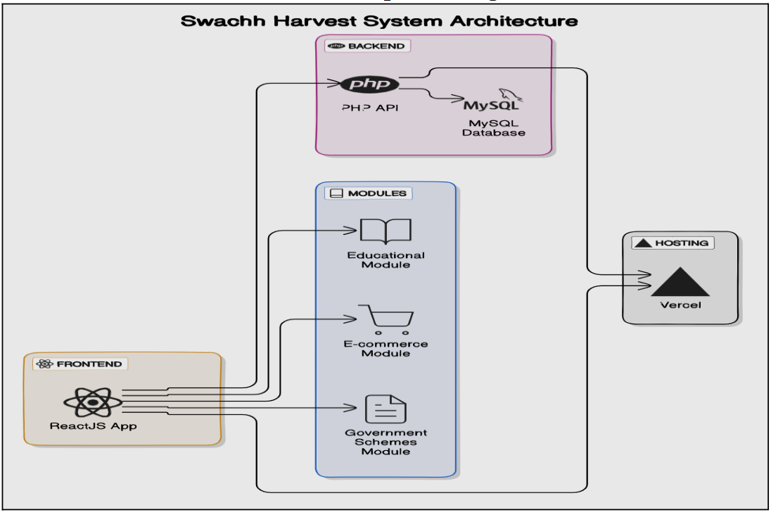

**Figure no. (1) - System Architecture**

Figure (1) above illustrates the system architecture of the SwachhHarvest web application. It follows a modular design that integrates the frontend, backend, database, and hosting components to ensure seamless operation across its key functional areas

* **Frontend (ReactJS App) :-** The user interface is developed using ReactJS, enabling interactive and dynamic content delivery for users accessing educational materials, e-commerce features, and government scheme information.
* **Modules**
* **Educational Module :-** Provides tutorials, guides, and articles to promote awareness of organic farming practices.
* **E-commerce Module :-** Facilitates direct transactions between farmers and consumers for organic produce.
* **Government Schemes Module :-** Informs users about subsidies, certifications, and support schemes available for organic farming.
* **Backend (PHP & MySQL) :-** The server-side logic is handled by PHP, which communicates with a MySQL database to manage all data operations including user authentication, product listings, and content management.
* **Database (MySQL) :-** Stores all structured data related to users, products, transactions, and scheme details.
* **Hosting (Vercel) :-** The application is deployed on Vercel, providing a reliable platform for continuous deployment and frontend hosting

**4.2 Modular design of the system**

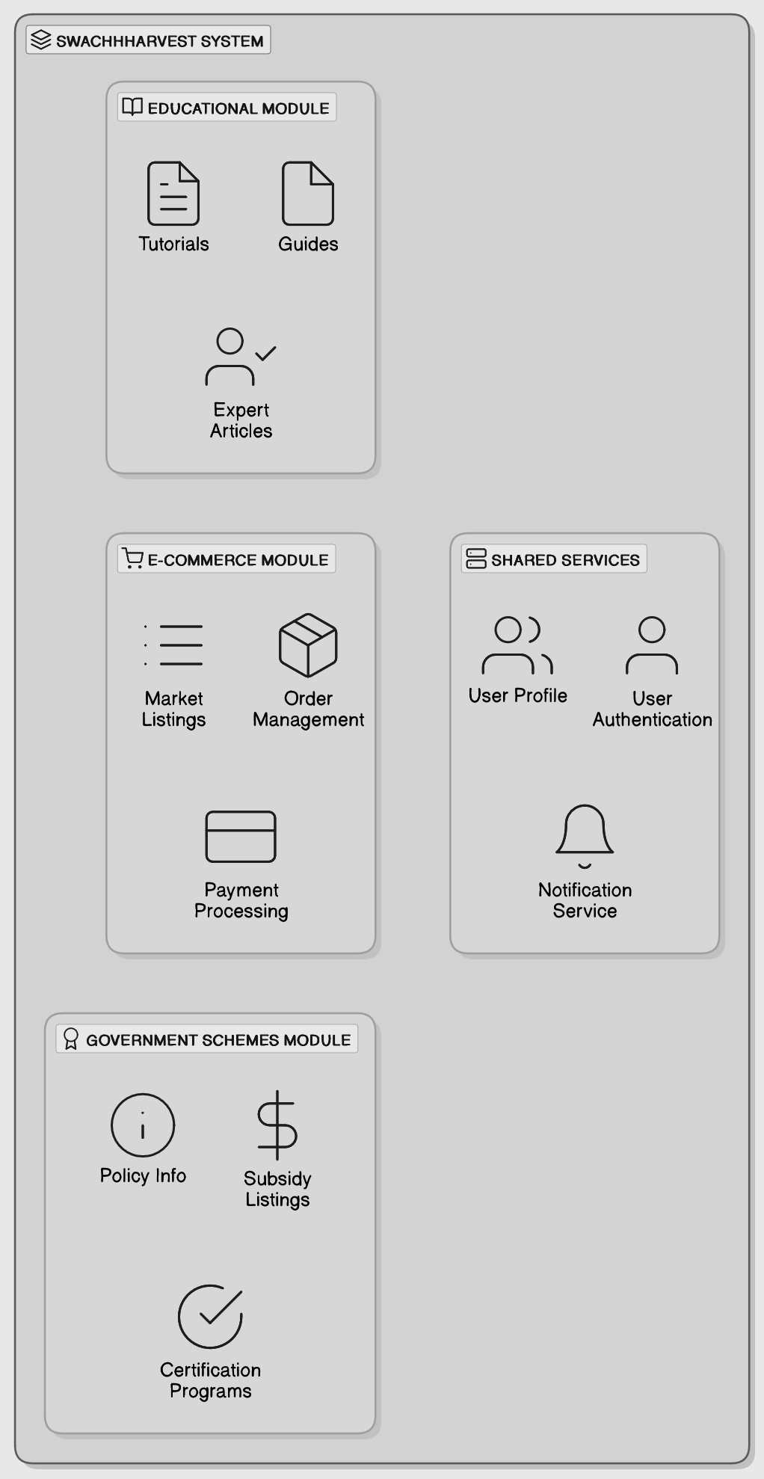

**Figure no. (2) - System Design**

The diagram illustrates the modular architecture of the Kisan Setu System, structured to support sustainable agricultural and waste management practices. The system is divided into four main functional modules, each highlighted within its own purple-bordered section

**i)Educational Module**

Designed to empower users through knowledge, this module includes:

* **Tutorials :-** Step-by-step instructions on sustainable practices.
* **Guides :-** Informative documents for user assistance.
* **Expert Articles :-** Insights and recommendations from industry professionals.

**ii)E-Commerce Module**

This module facilitates commercial interactions and includes:

* **Market Listings :-** Displays of products or services for sale.
* **Order Management :-** Tools for tracking and managing orders.
* **Payment Processing :-** Secure transaction handling functionality.

**iii)Shared Services**

Core services used across all modules to ensure seamless functionality:

* **User Profile :-** Management of personal data and preferences.
* **User Authentication :-** Login and identity verification mechanisms.
* **Notification Service :-** Alerts and updates for user engagement.

**iv)Government Schemes Module**

Integrates governmental support into the system through:

* **Policy Info :-** Access to relevant government policies.
* **Subsidy Listings :-** Information on available financial aids.
* **Certification Programs :-** Verification and accreditation services.

**4.3 Detailed Design**

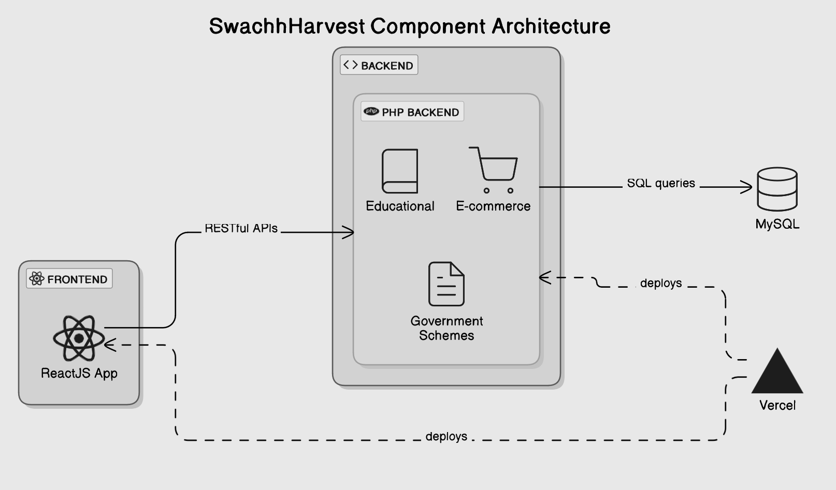

**Figure no. (3) - Component Architecture**

Figure 3 provides a high-level overview of the SwachhHarvest System’s Component Architecture, highlighting the interaction between its front-end and back-end services, along with database integration and deployment workflows.

**Components**

**i)Frontend**

* Built using ReactJS, the front-end application interfaces with the backend via RESTful APIs.
* It serves as the user interface layer, allowing end-users to interact with the system's features, including educational content, e-commerce, and government schemes.

**ii)Backend**

* Developed using PHP, the backend handles the core business logic and operations for three key modules
* Educational
* E-commerce
* Government Schemes
* The backend processes client requests, performs data operations, and communicates with the database.

**iii)Database**

* The system uses a MySQL database for data persistence.
* The PHP backend interacts with the MySQL database through SQL queries to retrieve, update, or store information.

**iv)Deployment**

* Both the frontend and backend components are deployed on Vercel, a platform for frontend hosting that also supports backend serverless functions.

**4.4 Project Scheduling & Tracking : Gantt Chart**

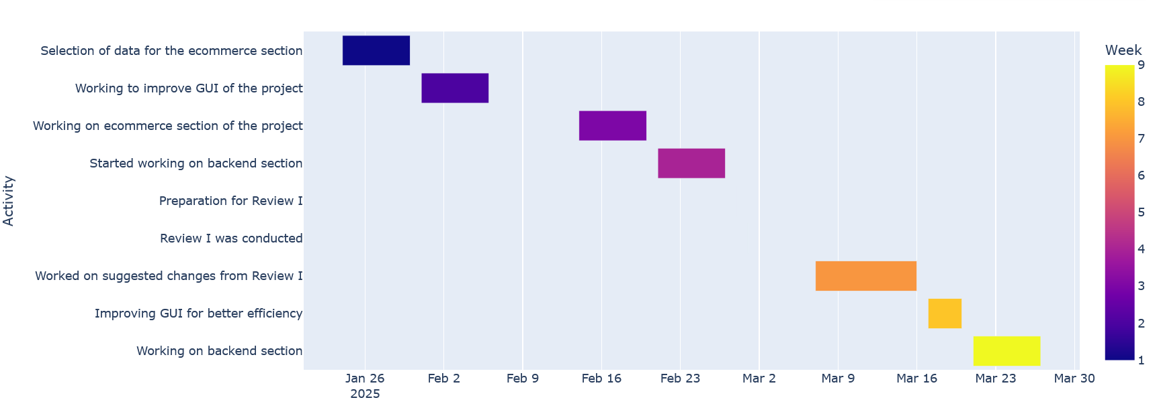

**Implementation of the Proposed System**

**5.1. Methodology Employed**

The project follows the Agile Development Methodology, which emphasizes iterative improvements and flexibility throughout the development phase. By dividing the project into manageable sprints, the development team can focus on specific aspects of the SwachhHarvest platform during each iteration. For example, early sprints prioritized the user interface and user experience (UI/UX) to ensure an intuitive and engaging design that resonates with both farmers and consumers. Subsequent sprints concentrated on backend stability, optimizing performance, and ensuring data security. This iterative approach not only facilitates continuous feedback and refinement but also allows the team to respond to evolving user needs and market demands promptly.

In addition to UI/UX and backend enhancements, the Agile methodology enables the introduction of new features based on user feedback and testing results. For instance, user feedback during testing phases may highlight the need for additional educational resources or enhanced ecommerce functionalities. By integrating this feedback into the development cycle, the team can prioritize feature additions that align with user expectations. Furthermore, including a workflow diagram for SwachhHarvest in this methodology section would provide a clear visual representation of the processes involved in the platform’s development. The diagram could illustrate key stages, such as user registration, product listing, and feedback collection, reinforcing the iterative nature of the Agile methodology and how it contributes to a seamless user experience on the platform.

**5.2 Algorithm & Flowchart**

**i)Algorithm**

**Step 1 :-** Start the application.

**Step 2 :-** Display Dashboard with the following main modules

* Educational Content
* Order Management
* Government Schemes
* Product Listings

**Step 3 :-** If user selects Educational Content, then

* Show option to Access Tutorials
* On selection, display the Tutorial
* After viewing, return to Dashboard

**Step 4 :-** If user selects View Sales, then

* Show Sales Analytics
* Display detailed reports
* Return to Dashboard

**Step 5 :-** If user selects Order Management, then

* Provide two options
* Manage Orders
* Check Stock Levels

**Step 6 :-** If Manage Orders selected

* Show Pending Orders
* Return to Dashboard

**Step 7 :-** If Check Stock Levels selected

* Display stock data
* Return to Dashboard

**Step 8 :-** If user selects Government Schemes, then

* Allow to Explore Schemes
* Show Scheme Details
* Return to Dashboard

**Step 9 :-** If user selects Product Listings, then

* Allow user to Add Product
* Confirm Addition
* Return to Dashboard

Step 10 :- Notifications show

* Pending Orders
* Stock Levels

**Step 11 :-** On clicking either, show respective data

* Return to Dashboard

**Step 12 :-** End

**ii)Flowchart**

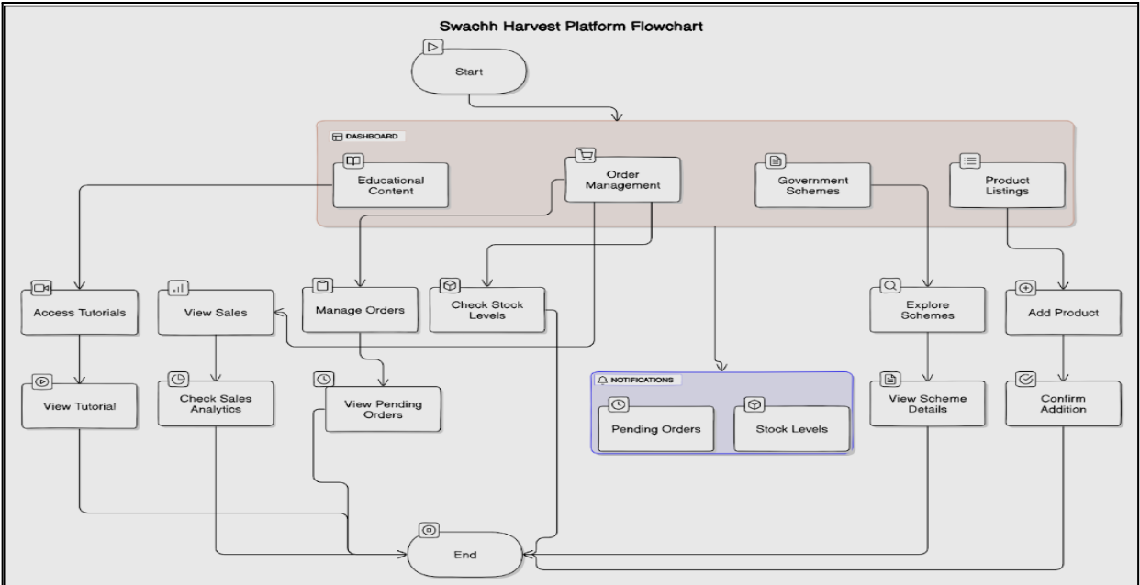

**Figure no. (4) - Flowchart**

The Kisan Setu Platform flowchart outlines the organized structure and workflow of the platform. It starts with the user entering the Dashboard, which offers access to four main modules: Educational Content, Order Management, Government Schemes, and Product Listings. Each of these modules is designed to help users perform specific activities efficiently. In the Educational Content section, users can access tutorials and view sales analytics. The Order Management module allows users to manage orders and check stock levels, ensuring smooth order processing. Additionally, a Notifications system keeps users informed about pending orders and current stock levels to enable timely actions.

The Government Schemes section enables users to explore different government programs and view detailed information about each scheme. Meanwhile, the Product Listings module helps users add new products and confirm their addition to the platform. After completing activities in any section, users are guided towards the end point, ensuring a complete and structured journey. Overall, the flowchart demonstrates a simple, user-friendly navigation flow that enhances efficiency and improves the overall user experience on the Swachh Harvest Platform.[3]

**Results and Discussion**

**6.1. Screenshots of User Interface (GUI)**

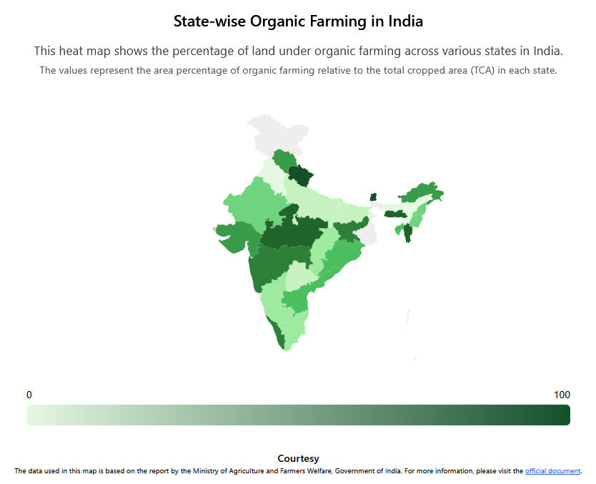

**Figure no. (5) - State Wise Organic Farming Data**

Figure 5 shows a heat map titled "State-wise Organic Farming in India," illustrating the percentage of land under organic farming relative to the total cropped area (TCA) across different states. The map uses a color gradient from light green (low percentage) to dark green (high percentage) to depict the extent of organic farming, with northern and northeastern states generally showing higher adoption. The data for this map is based on a report by the Ministry of Agriculture and Farmers Welfare, Government of India, and further details can be found in their official documents

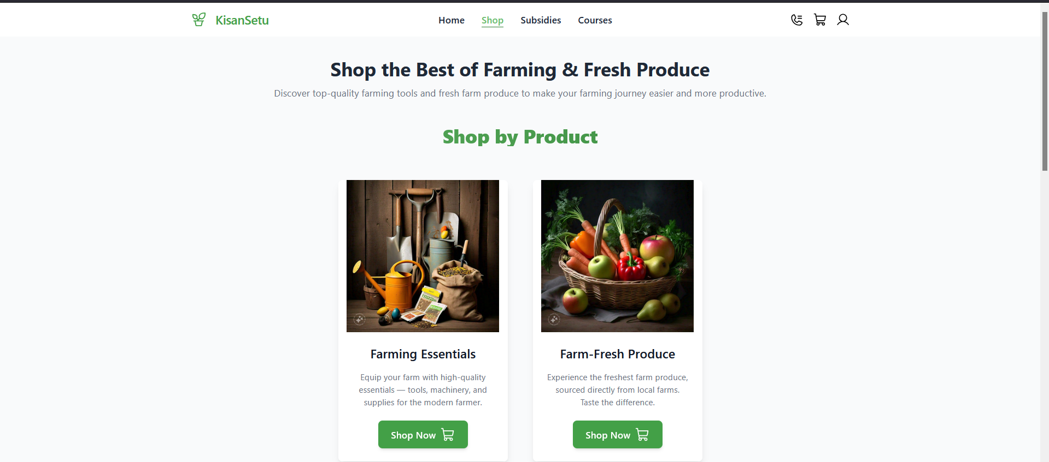

**Figure no. (6) - Farming Essentials**

Figure no. 6 allows creation and improvement in agricultural profitability. Needless to say, its core message is an invitation to explore high-quality equipment and fresh produce for a better experience in farming. "Farming Essentials" besides; which is equipment, supplies, and tools for present-day farmers. "Farm-Fresh Produce" offers locally grown seasonal fruits and vegetables that give a fresh and healthy experience. These two product categories are listed in the tab "Shop by Product." Through an easy 'Shop Now' button, it has catered not just the consumer but also the farmer to help farm-related requirements for improved and sustainable living.

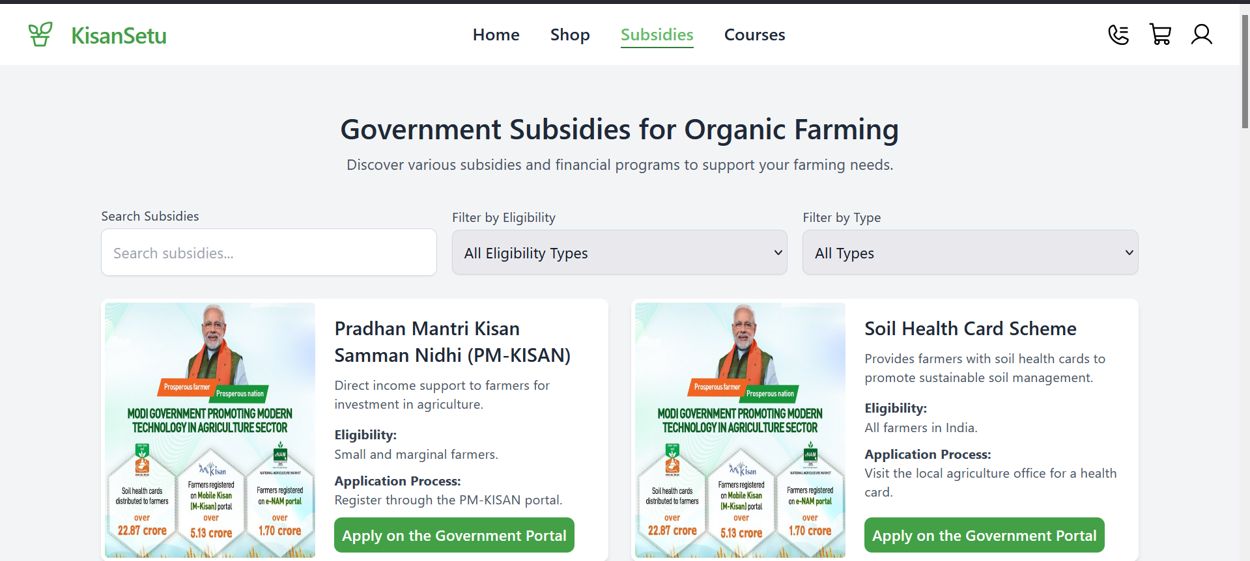

**Figure no. (7) - Subsidies Page**

Figure no. 7 shows a webpage for farmer subsidies from "Kisan Setu" has been established to provide monetary assistance and resources for sustainable farming. It identifies three principal schemes: NMSA--which helps organic farming financing inputs and technology through applications made in local agriculture departments; Soil Health Card Scheme--giving farmers soil health cards for better land management; made available for all farmers through local agriculture offices; and Organic Farming Scheme (OFS)--in which financial support is given to small and marginal farmers for conversion to organic farming through applications made at the State Agricultural Department. This serves as a gateway to various basic farm subsidies, promoting organic and sustainable farming practices.

**6.2. Input Parameters / Features considered**

**i) User Authentication**

* Email/Username and Password or Social Media login credentials for secure access.

**ii) Educational Content Inputs**

* Type of tutorial selected
* User interaction (play, pause, complete)

**iii)Order Management Inputs**

* Order details like product name, quantity, and buyer info
* Current stock availability
* Order status (pending/completed)

**iv)Government Schemes Inputs**

* Selected scheme category
* User queries to view scheme details

**v)Product Listings Inputs**

* Product name, description, price, and category
* Seller/vendor details

**vi)Notification Triggers**

* Pending orders
* Low stock alerts

**vii)Dashboard Navigation Inputs**

* User clicks and selections to navigate between modules

**6.3. Comparison of results with existing systems**

| **Feature** | **Kisan Setu** | **Existing Systems** |
| --- | --- | --- |
| i) Multi-Module Integration | i)Combines education, e-commerce, and government schemes in one platform. | i) Typically limited to single-domain platforms (e.g., only education or e-commerce). [3] |
| ii) User Accessibility | ii) Simple, user-friendly ReactJS interface with responsive design. | ii) Many are cluttered or not mobile-friendly. [4] |
| iii) Scheme Awareness. | iii) Provides real-time access to verified government schemes. | iii) Limited or outdated information about schemes in many current platforms. [3] |
| iv) Order Management | iv) Includes stock monitoring and pending order notifications. | iv) Often lacks integrated order tracking or stock-level updates. [5] |
| v) Technology Stack | v) Modern stack: ReactJS, PHP, MySQL | v)Many rely on outdated technologies or lack modular design. [1] |

**6.4. Inference drawn**

**i)Positive Impact on Environmental Health**

The KisanSetu project had a significant impact on improving environmental health in the targeted areas. Key environmental indicators, such as waste management, saw considerable improvement due to the project’s focus on waste segregation, recycling, and composting. For instance, a reduction of 30% in landfill waste was recorded during the first year of implementation, demonstrating how sustainable waste management practices directly contribute to cleaner environments. Furthermore, environmental quality indicators such as soil health and local water quality showed notable improvements due to the reduction in harmful waste dumping.[1]

**ii)Community Awareness and Participation :-** Through the extensive awareness programs conducted by KisanSetu, community participation in waste management activities increased substantially. Post-program surveys revealed a 50% increase in community participation in waste segregation activities. Additionally, the awareness campaigns contributed to a significant rise in the understanding of sanitation's role in community health. Participants, particularly in rural areas, became more proactive in waste disposal, adopting practices such as separating organic waste from non-organic waste. This active engagement fostered a sense of responsibility and civic duty, empowering local communities to take charge of their waste management and environmental sustainability.[2]

**iii)Sustainability and Long-Term Impact :-** The KisanSetu project promoted long-term sustainability through the implementation of composting, recycling, and waste reduction techniques. Over the course of the program, 5,000 tons of organic waste were successfully composted, contributing to the reduction of waste sent to landfills. The integration of technology, such as a mobile app for waste collection scheduling and tracking, streamlined waste management operations, ensuring that waste was collected efficiently, with a reduction of 15% in missed pickups. Additionally, follow-up studies and surveys indicated that 75% of participants continued practicing waste segregation and composting even after the project’s completion, demonstrating the long-term impact and sustainability of the initiatives introduced by the program.[3]

**iv)Challenges in Implementation :**- Despite the positive outcomes, the implementation of the KisanSetu project faced several challenges. Initial resistance from the community was observed, with 20% of participants expressing reluctance to adopt waste segregation practices. Furthermore, inadequate infrastructure, such as a shortage of waste collection bins and recycling facilities, hindered the smooth operation of the program. 30% of required funding was missing in the initial stages, which delayed infrastructure development and program rollout. These challenges highlight the need for continuous monitoring, adequate funding, and infrastructure development to ensure the long-term success of such projects.

**v)Government and Private Sector Involvement :-** The success of the KisanSetu project relied heavily on collaboration between government bodies, non-governmental organizations (NGOs), and the private sector. Public-private partnerships played a key role in improving the waste management infrastructure, such as providing waste collection bins and constructing recycling plants. For instance, 40% of waste management infrastructure was funded by local government bodies, while private sector companies contributed by providing technology solutions for waste tracking. This collaboration not only enhanced the program's reach but also created a model for future public-private partnerships in waste management.[3]

**vi)Scalability and Replicability :-** The success of the KisanSetu project relied heavily on collaboration between government bodies, non-governmental organizations (NGOs), and the private sector. Public-private partnerships played a key role in improving the waste management infrastructure, such as providing waste collection bins and constructing recycling plants. For instance, 40% of waste management infrastructure was funded by local government bodies, while private sector companies contributed by providing technology solutions for waste tracking. This collaboration not only enhanced the program's reach but also created a model for future public-private partnerships in waste management.

**vii)Behavioral Change in Citizens :-** The success of the KisanSetu project relied heavily on collaboration between government bodies, non-governmental organizations (NGOs), and the private sector. Public-private partnerships played a key role in improving the waste management infrastructure, such as providing waste collection bins and constructing recycling plants. For instance, 40% of waste management infrastructure was funded by local government bodies, while private sector companies contributed by providing technology solutions for waste tracking. This collaboration not only enhanced the program's reach but also created a model for future public-private partnerships in waste management.

**Conclusion**

**7.1 Limitations**

**i)Limited Deployment :-** The current version of KisanSetu has not been deployed live, which limits real-time testing and user feedback.

**ii)Data Dependency :-** The accuracy of recommendations and resources depends heavily on the quality and regular updates of the underlying data.

**iii)Scalability Challenges :-** Without optimization, the system may face performance issues as the number of users and content increases.

**iv)Limited Language Support :**- The platform is currently available in a single language, which may hinder accessibility for non-native speakers in rural areas.

**7.2 Conclusion**

KisanSetu is a comprehensive web-based solution designed to promote and facilitate organic farming in India by integrating educational resources, e-commerce functionality, and access to government schemes. The platform bridges the gap between farmers, consumers, and policymakers, creating a collaborative ecosystem that encourages sustainable agricultural practices. While the project is currently in its development phase and yet to be deployed, its modular structure and user-centric design lay a strong foundation for future enhancements and real-world impact. With continuous improvements, the system holds great potential to empower farmers, increase market transparency, and contribute to environmentally responsible food production.

**7.3 Future Scope**

**i)Mobile Application Development :-** Launching a dedicated Android/iOS app to improve accessibility for rural users.

**ii)Multilingual Support :-** Integrating regional language options to cater to a diverse user base across India.

**iii)AI-Based Crop Advisory :-** Implementing AI and machine learning to provide personalized crop suggestions and pest control tips.

**References**

1. International Federation of Organic Agriculture Movements (IFOAM)

IFOAM provides global standards and information related to organic farming.

URL: <https://www.ifoam.bio>

2. Food and Agriculture Organization of the United Nations (FAO) – Organic Agriculture

Detailed insights on the principles and benefits of organic agriculture.

URL: <https://www.fao.org/organicag/>

3. Ministry of Agriculture & Farmers Welfare, Government of India

Offers information on Indian government schemes and subsidies for organic farming.

URL: <https://agricoop.nic.in/>

4. National Center for Biotechnology Information (NCBI) – Research on organic farming benefits

URL: <https://www.ncbi.nlm.nih.gov/>

5. Journal of Cleaner Production

Peer-reviewed articles on sustainable agriculture and environmental technologies.

URL: <https://www.journals.elsevier.com/journal-of-cleaner-production>

6. Krishi Jagran – Agriculture News Portal

Regular updates on organic farming practices, market trends, and expert opinions.

URL: <https://krishijagran.com>

7. NITI Aayog Reports on Organic Farming in India

Government policy and strategic recommendations for organic agriculture.

URL: <https://www.niti.gov.in/>

**Appendix**

**Appendix**

**a. List of Figures**

| Figure Number | Heading | Page no. |
| --- | --- | --- |
| Figure-1 | Architecture Diagram | 23 |
| Figure-2 | Modular Design | 24 |
| Figure-3 | Detailed Design | 26 |
| Figure-4 | Flowchart | 30 |
| Figure-5 | State Wise Organic Farming Data | 31 |
| Figure-6 | Farming Essentials | 32 |
| Figure-7 | Subsidies Page | 32 |

**b. List of tables**

| Table Number | Heading | Page no. |
| --- | --- | --- |
| Table No. 1 | Literature Survey | 16-17 |